**AMRITA VISHWA VIDYAPEETHAM**

**BANGALORE CAMPUS- 560035**



**Department: Electronics and Communication Engineering (ECE)**

**IV Semester**

**Electronics and Computer Engineering (EAC)**

**19EAC285-Microprocessor and Microcontroller Lab**

Team Members:

Janani J – BL.EN.U4EAC21026

Kurukundu Dhanush Sai- BL.EN.U4EAC21036

Ramu Keerthana P – BL.EN.U4EAC21055

**Signature of Students:**

**Signature of the Faculty:**

**Aim:**

Interfacing Seven Segment With LPC2148

**Tool Used:** Keil uVision 4, Proteus 8

**Theory:**

Interfacing a seven-segment display with the LPC2148 microcontroller is a common project in embedded systems. A seven-segment display is a type of electronic display device that can represent decimal numerals using a combination of seven segments. The LPC2148 is an ARM-based microcontroller commonly used in various embedded systems applications.

Here's a general outline of the theory behind interfacing a seven-segment display with the LPC2148:

1. Seven-Segment Display: A seven-segment display consists of seven individual LED segments (a-g) arranged in a pattern that can display numerals from 0 to 9 and some additional characters like A, b, C, d, E, F, etc. Each segment is connected to a separate pin of the display.

2. Pin Configuration: Identify the pin configuration of the seven-segment display you are using. It typically consists of eight pins, including seven pins for individual segments (a-g) and one common pin (usually denoted as COM or DP) used for multiplexing or controlling the decimal point.

3. Microcontroller Pin Connections: Determine the pins of the LPC2148 microcontroller that will be connected to the seven-segment display. You can use any GPIO (General-Purpose Input/Output) pins of the microcontroller for this purpose.

4. Multiplexing: To display multiple digits on a single seven-segment display, multiplexing is often used. In this technique, the display cycles through each digit at a high frequency, creating an illusion of all digits being displayed simultaneously. For example, if you have two seven-segment displays to show a two-digit number, you would alternate between displaying the digits on each display.

5. Driving Logic: You will need to implement the driving logic to control which segments are illuminated for each digit. This can be done using either a common cathode or a common anode configuration. In the common cathode configuration, the common pin is connected to ground, and each segment pin is connected to a microcontroller pin through a current-limiting resistor. By setting the appropriate pins high or low, you can control which segments are lit up.

6. Software Implementation: Write the firmware code to control the microcontroller pins connected to the seven-segment display. This involves initializing the GPIO pins, implementing the multiplexing technique, and driving the segments to display the desired numbers or characters. You can use the LPC2148's GPIO control registers to set the pin states.

7. Testing and Debugging: After writing the code, compile and upload it to the LPC2148 microcontroller using an appropriate programming tool. Connect the microcontroller pins to the seven-segment display as per the pin configuration determined earlier. Power up the circuit and test the display by sending different numbers or characters to be displayed.

Remember to refer to the datasheets and user manuals of both the LPC2148 microcontroller and the seven-segment display for detailed information on pin configurations, electrical characteristics, and programming instructions. Additionally, there are numerous online resources, tutorials, and example projects available that can provide you with step-by-step instructions and code examples for interfacing a seven-segment display with the LPC2148 microcontroller.

**Circuit Diagram:**

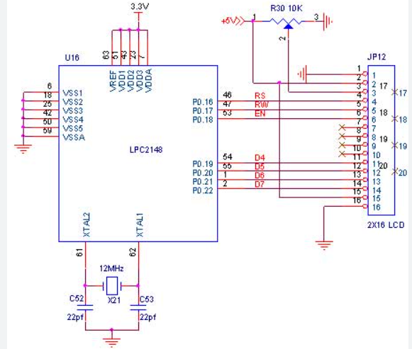

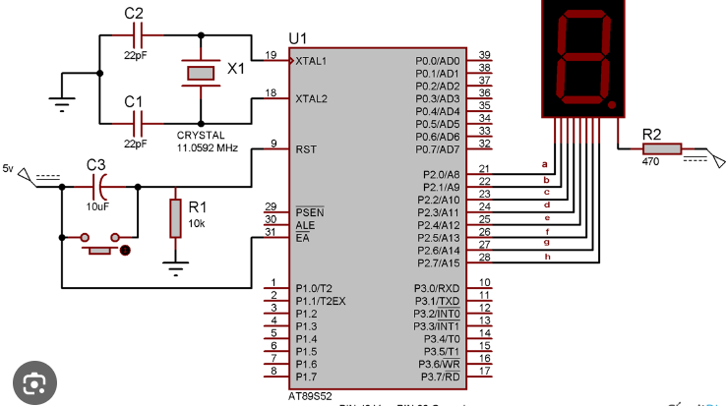

**Program:**

#include <LPC214X.H>

unsigned char test[] = {0x3f,0x06,0x5b,0x4f,0x66,0x6d,0x7d,0x07,0x7f,0x6f};

void delay()

{

int k;

for(k=0;k<100000;k++);

}

int main()

{

int j;

IO0DIR = 0xff;

while(1)

{

for(j=0;j<10;j++)

{

IO0SET = test[j];

delay();

IO0CLR = 0xff;

}

}

}

**Screenshot of the output:**

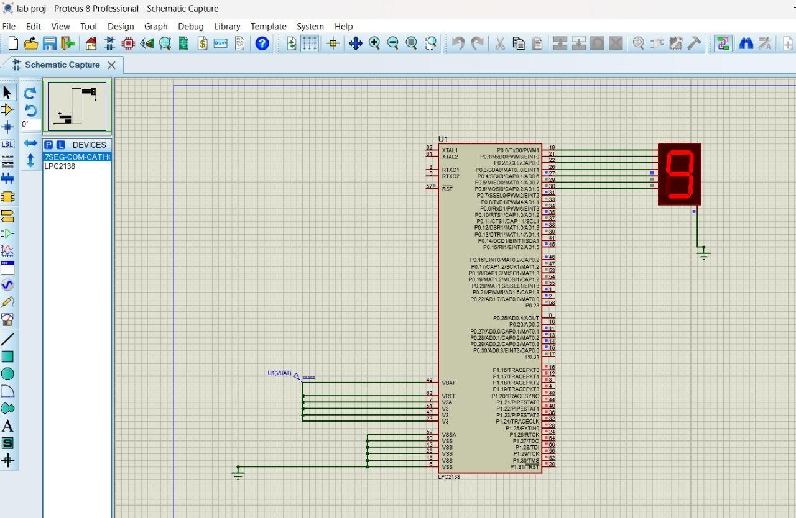

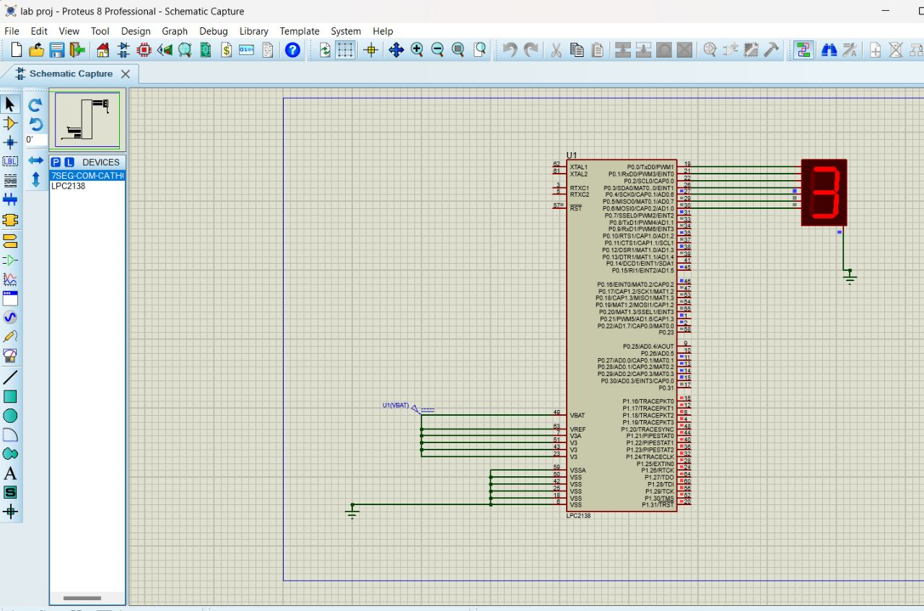

**Result:**

C program is used to interface Seven Segment Display with LPC 2148 using Keil micro vision 4 tool was written and the code was imported to proteus software to perform the simulation using Proteus tool .The simulation was successful, and output has been Verified.

**Conclusion:**

Display is a very important part of any Embedded System Application as it helps users to know the status of the system and also shows the output or any warning message generated by the system. This can be achieved using the Seven Segment Display with LPC 2148.